Alcoholics Anonymous Area 8 

38th Annual

# ROOTS

**Remember Our Old Timers’ Stories**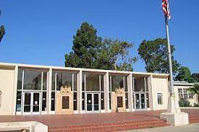

JOIN US AT THE WAR MEMORIAL BUILDING IN BALBOA PARK

3325 Zoo Drive San Diego, CA 92103

[Click here for Google Map and Directions](https://maps.app.goo.gl/wYWtLHNDFbR1a7F79)

ON SUNDAY NOVEMBER 19TH 2023

FROM 12-2

by Alcoholics Anonymous Area 8 Archives Committee

GO BACK IN TIME TO AA IN THE 80’S AND BEFORE!

**4 SPEAKERS WITH 40+ YEARS OF SOBRIETY**



Bring cookies to share There will be coffee and tea

Sign language & Spanish Translation

|  |
| --- |
| [**SEE AUTHENTIC MAP FROM 1990**](https://aasandiego.org/wp-content/uploads/2021/05/1990.pdf) |

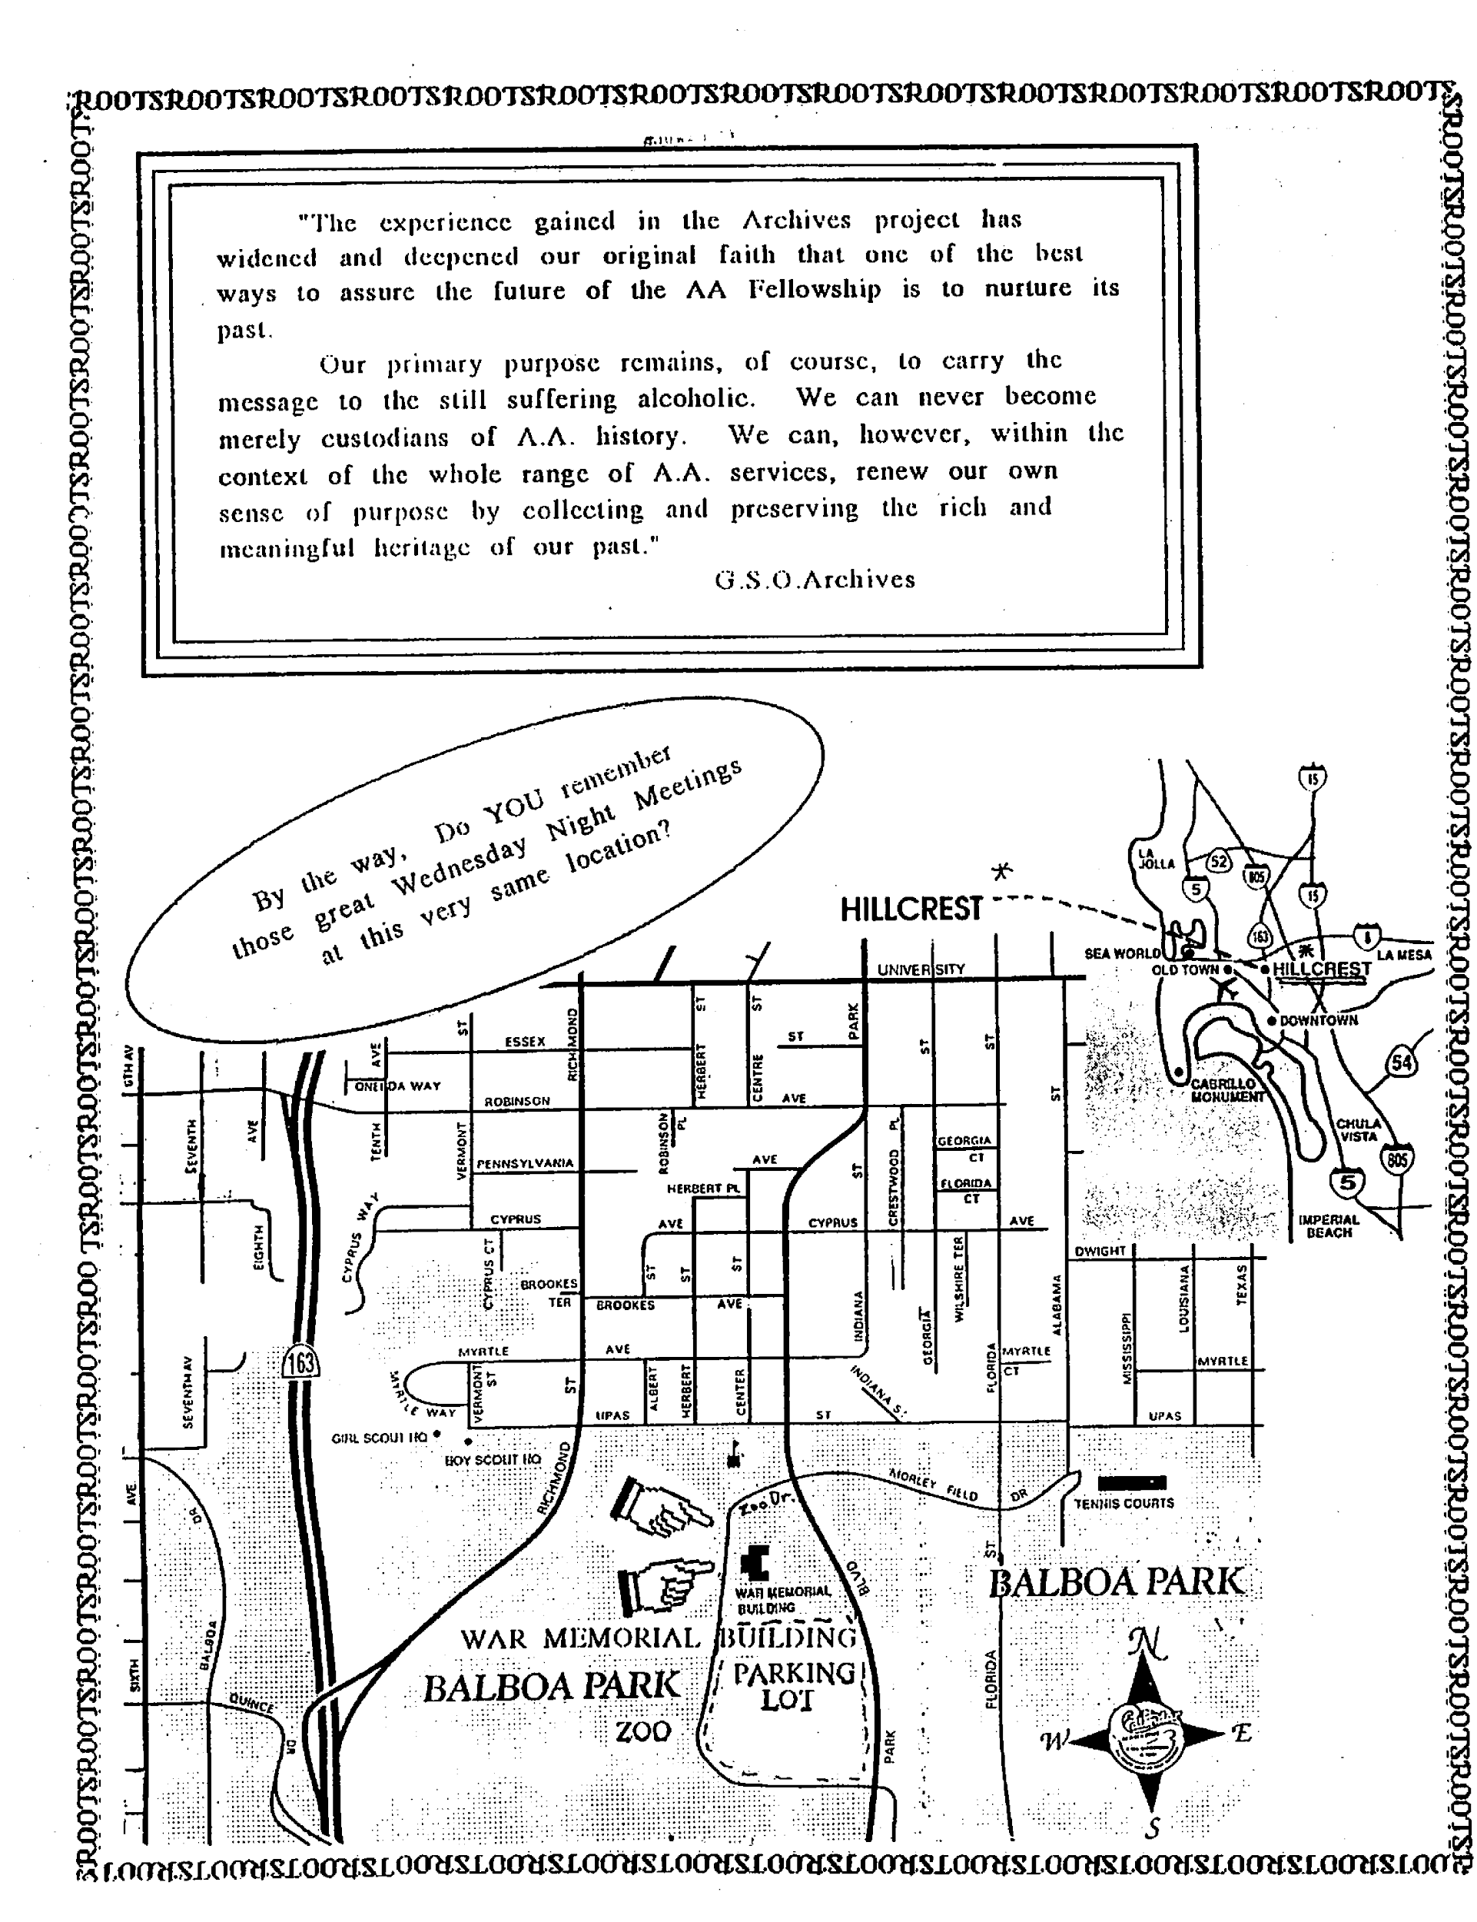This map is copied from the 1990 ROOTS flyer in the October Coordinator Newsletter